Marketing Research
women’s dresses party
01]

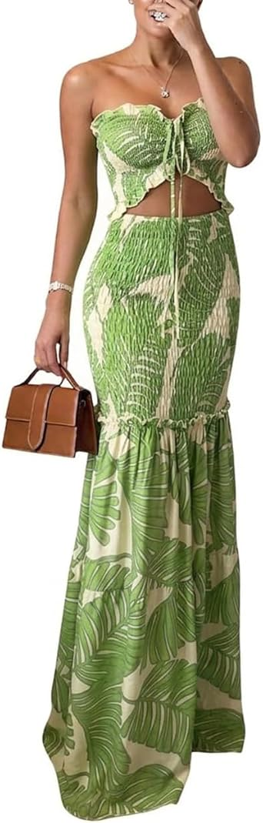
CHICME Floral Printed Vacation Dress Halter Tie Ruched Shirred Bandeau Party Dress Slim Ruffle Hem Wedding Guest Dress
LKR 15,245.68LKR15,245.68

Product details
Top highlights
Fabric type
15% POLYAMIDE,85% VISCOSE
Care instructions
Machine Wash
Origin
Imported
Closure type
Pull On

About this item
- Material: The prom dress made of 85% viscose, 15% polyamide. Adopts the close fitting style and mermaid hem design, your body curve could be highlighted, show your noble and elegant
- Versatile Front Tie: It can be worn as a halter strap, tied into a decorative bow, or tucked into the dress to create a strapless look. These three styling options make it effortless to create a fashionable ensemble. It is recommended that girls under 170cm tall can wear high heels to achieve the best dressing effect
- Ruching Design: This bodycon dress features ruched tailoring with stretch elasticity, hugging your curves flawlessly. The dynamic ruched expand with movement for a slimming yet comfortable fit, perfect for versatile occasions
- Flounced Hem: The printed mermaid party dress features delicate ruffled detailing, with a mermaid hem that blossoms like petals, exuding romantic charm. The stylish print design makes it perfect for beach weddings, banquets, and festive parties
- Occasions: This strapless floral print dresses for women long ruffles formal dress perfect for many occasions, such as wedding prom party dresses, vacation dress
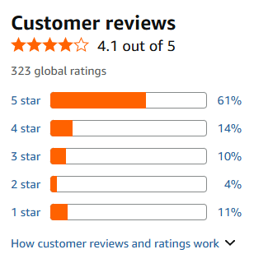
https://www.amazon.com/CHICME-Printed-Drawstring-Shirred-Bandeau/dp/B0FHQ5T72Z/ref=sr_1_29?crid=2QIA9RG3MIZZA&dib=eyJ2IjoiMSJ9.mCKHiU7FzhsQY4c0T093N7mpTtXtlZtXBATB9eA84XufGm3RAUHKee12jOfh4YToWd5qlJmLQEZg3Eiu7W8qLdBBr0hdbaGB3PRjIyVZ2jM0Np67nb53YOGVDla628_1e5QtPMMSQ3ULpfzgEEPnbJf3IEkBJ3IaSkotF7E_o5rU1wxvgQZsDyRKrIby-AvzRBbXr5qi2ToY1Aj9rB2vgKoqu9tk5dlbIx9s_SbORDMXdfE2bwXmPpq6AvnW-dytSoBIySUCNT5vgzBX58XSnbUsDXeLhrckJ8W9PzKtR5M.Ik-ZgF__6MYGqYBnjX_yXRXIq02iTC4D8W-u-JsER0E&dib_tag=se&keywords=womens%2Bdresses%2Bparty&qid=1780381931&sprefix=womens%2Bdresses%2Bpa%2Caps%2C360&sr=8-29&xpid=_OlPUQsIfpuyN&th=1&psc=1

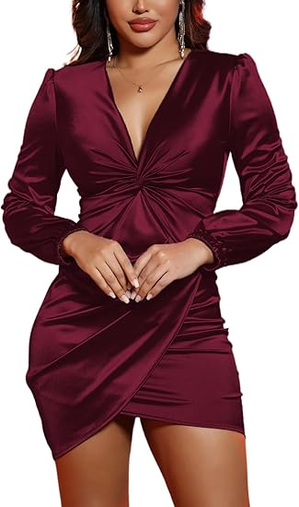
02]

DeftSharp Womens Ruched Formal Bodycon Zipper Graduation Dresses-Elegant Cocktail Party Wedding Midi Dress
LKR 14,579.37LKR14,579.37
Product details
Top highlights
Fabric type
95% polyester 5% spandex,Women's Cute cocktail dresses is made by lightweight and skin-touch Fabric,good quality soft stretchy fabric which is Comfortable and Breathable to wear
Care instructions
Hand Wash Only
Origin
Imported
Closure type
Zipper

About this item
- The twisted knot detail at the bust creates a 3D draped silhouette,lifting the bust and cinching the waist with radial folds.Featuring a ruched front,deep V-neck,slim bodycon fit,it is a midi dress suitable for summer and fall.With a hips-wrapped silhouette,it is an elegant cocktail-style piece,equipped with a zipper at the back for easy on and off.
- Wedding Guest Dresses for Women is Really Nice and Feminine.Fashion and Simple Cut Outfit,it Fits all Your Curves.Bodycon midi Length,Hidden Zipper in the Back
- This Elegant Vintage Formal Midi Dress is Suitable for Daily,Cocktail,Wedding Guest,Party,Graduation,Birthday,Champagne,Dinner,Night Out,Vegas,Homecoming,Disco,Beach and Other Special Occasion
- This Evening Bodycon Midi Classy Cocktail Wedding Guest Dress have many colours as Black/Purple/Royal Blue/Burgundy.Pair it with high heel in spring/summer/autumn/Fall and Winter will be eye-catching anywhere.
- Please refer to the dimension drawing on the left before purchasing.As it is measured manually, there may be a gap of 1-2 cm between the real objects;Different computers display different colors,and the actual product color may be slightly different from the above figure.Thanks for your understanding.

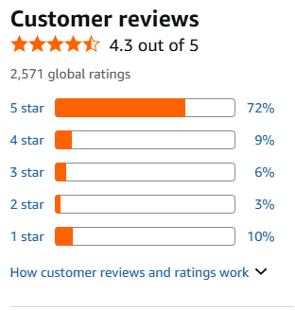
https://www.amazon.com/DeftSharp-Womens-Ruched-Formal-Bodycon/dp/B0B3J6MRNV/ref=sxin_14_pa_sp_search_thematic_sspa?content-id=amzn1.sym.a6b4529a-c41f-4cb8-b893-3e18e4cfe667%3Aamzn1.sym.a6b4529a-c41f-4cb8-b893-3e18e4cfe667&crid=2QIA9RG3MIZZA&cv_ct_cx=womens%2Bdresses%2Bparty&keywords=womens%2Bdresses%2Bparty&pd_rd_i=B0B3J61CBX&pd_rd_r=f4b1a366-1c48-4fd5-8b18-631784d446e0&pd_rd_w=izSIQ&pd_rd_wg=wdDTZ&pf_rd_p=a6b4529a-c41f-4cb8-b893-3e18e4cfe667&pf_rd_r=QAKYMXRT4ZV07H0SNYRY&qid=1780381407&sbo=RZvfv%2F%2FHxDF%2BO5021pAnSA%3D%3D&sprefix=womens%2Bdresses%2Bpa%2Caps%2C360&sr=1-52-f853d353-bf33-45e7-b5c2-2cb2b31abc9b-spons&xpid=_OlPUQsIfpuyN&aref=vrYsea2vqp&sp_csd=d2lkZ2V0TmFtZT1zcF9zZWFyY2hfdGhlbWF0aWM&th=1&psc=1

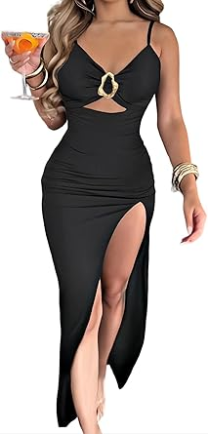
03]

Women Bodycon Dress High Slit Cut-Out Midi Dress Metal Ring Decor V-Neck Spaghetti Straps Cocktail Party Dress
LKR 12,262.18LKR12,262.18

Product details
Top highlights
Fabric type
95% Polyester, 5% Elastane
Care instructions
Machine Wash
Origin
Imported
Closure type
Pull On

About this item
- Fabric –This sexy party dress is crafted from a premium blend of 95% polyester and 5% elastane, delivering high stretch and a soft, comfortable feel. The lightweight fabric hugs your curves and adds a sleek finish, ideal for party dresses for women
- Design –This evening bodycon dress features a daring V-neck, hollow-out waist cutouts, and a bold high slit. The standout metal ring decor and adjustable spaghetti straps offer both edge and elegance, perfect for chic night-out looks
- Occasion –This high slit maxi dress is your go-to for spring and summer events, including evening parties, cocktail nights, clubwear, and weddings. A bold choice for women looking for elegant yet sexy summer dresses
- Styling –This sleeveless party dress is easy to style with strappy heels, statement earrings, or a leather jacket for a more edgy vibe. A must-have for womens party dresses 2025 and fashion-forward wardrobes
- Care –This V-neck maxi dress is both practical and stylish, with easy machine wash or professional dry clean care. The quality stitching and fabric keep its shape and shine, ideal for dresses for women summer special occasions

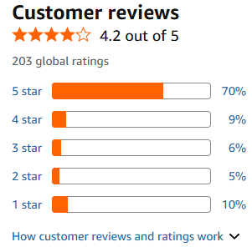
https://www.amazon.com/Ninimour-Hollow-Out-Adjustable-Spaghetti-Dresses-bk-S/dp/B0FBWWJLG7/ref=sr_1_21_sspa?crid=2QIA9RG3MIZZA&dib=eyJ2IjoiMSJ9.mCKHiU7FzhsQY4c0T093N7mpTtXtlZtXBATB9eA84XudcWoiVMiEmuyn5OFU4DLPxV7qncLBHrEgnkpKkeyGudBBr0hdbaGB3PRjIyVZ2jM0Np67nb53YOGVDla628_1e5QtPMMSQ3ULpfzgEEPnbJf3IEkBJ3IaSkotF7E_o5qq4nZvARS3nRAZoJtNRQ21m1T4lhqmkMVTBqRACtKP_f4EV7DQJ5oPwZKFTauMkjOF_jCsLLxw04vnkVBKXFG0Of-71BJuzygH7B4NSb_QijYpJuMJTK2gs4_9B2WFrlM.UZ8-HVHKC5vs8MB8DLjGBzWEgVkm6z4htd-_G6SG_mc&dib_tag=se&keywords=womens%2Bdresses%2Bparty&qid=1780384763&sprefix=womens%2Bdresses%2Bpa%2Caps%2C360&sr=8-21-spons&xpid=_OlPUQsIfpuyN&sp_csd=d2lkZ2V0TmFtZT1zcF9tdGY&th=1&psc=1

04]

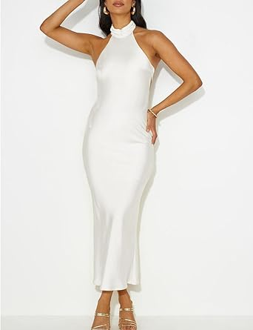
Phicia Sexy Satin Halter Neck Backless Maxi Dress for Women Elegant Tie Cowl Back Formal Wedding Guest Dress for Summer
LKR 16,571.68LKR16,571.68

Product details
Top highlights
Fabric type
100% Polyester
Care instructions
Hand Wash Only
Origin
Imported
Closure type
Button

About this item
- Material:The satin dress for women is made of smooth polyester fabric, our formal dresses for curvy women are soft, comfortable, and breathable, making it perfect for wedding guests. The cool fabric ensures that you won't feel sweaty or uncomfortable throughout the day. Additionally, the satin material gives the dress an elegant and luxurious look, making you stand out at any event
- Design:This silk midi dress, featuring a halter neck and open back criss cross spaghetti strap design,flowy skirt, that exudes elegance and sexiness. Earn your style points in the backless maxi dress
- Size:Forest green, Blue, Yellow, Sage high neck maxi wedding guest dress for women.PHICIA backless maxi dress with sizes--Small=US 2-4, Medium=US 6-8, Large=US 8-10, XLarge=US 10-12,refer to the graduation dress size chart and then choose what's suitable
- Features: Summer dresses for women 2025/Satin dresses for women elegant/Halter wedding guest dress/Silk dress for women wedding guest/Midi dress for wedding guest/High neck dress/Backless maxi dress for women/Formal dresses for curvy women/Women's cocktail dresses/Open back dress/Bridesmaid dresses/Homecoming dresses for teens/Graduation dress
- Versatile:This wedding guest dress is suitable for multiple occasions, making it a versatile piece in your wardrobe. It can be worn as a casual summer dress and homecoming dresses, for a evening party, or a club night. Pair it with different styles of high heels to create a variety of looks, making it adaptable to different temperatures. You'll be turning heads wherever you go with this fashion and cute dresses
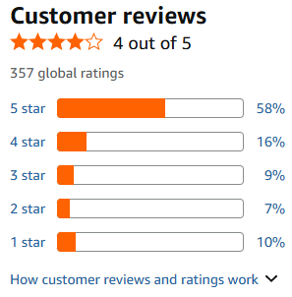
https://www.amazon.com/dp/B0CP8T6XDQ/ref=sspa_dk_detail_1?pd_rd_i=B0CKT4Z4FH&pd_rd_w=VjGZq&content-id=amzn1.sym.9bd45040-31dd-4792-bd5a-341290ebe305&pf_rd_p=9bd45040-31dd-4792-bd5a-341290ebe305&pf_rd_r=DNRPSJKSYVS24J1NJ3EH&pd_rd_wg=m83yV&pd_rd_r=68ba297e-1a95-49d6-985a-523d468754a4&sp_csd=d2lkZ2V0TmFtZT1zcF9kZXRhaWxfdGhlbWF0aWM&th=1&psc=1

05]

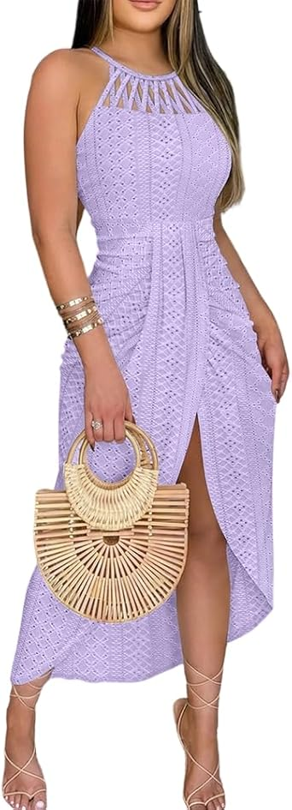
CHICME Womens Summer Halter Ruched Bodycon Long Dresses Hollow Out A Line Eyelet Embroidery & Side Slit Vacation Tank Dress
LKR 12,925.18LKR12,925.18

Product details
Top highlights
Fabric type
93% POLYESTER,7% ELASTANE
Care instructions
Machine Wash
Origin
Imported
Closure type
Drawstring

About this item
- Elegant Dresses for Women: This elegant maxi dress features a daring side slit and an asymmetrical hemline, adding a touch of allure. The strapless halter neckline offers a sleek, modern look making it perfect for both beachside strolls and evening outingss.
- Refined Eyelet Embroidery: Delicate eyelet embroidery adorns the dress, providing a refined and sophisticated touch. This intricate detailing elevates the overall appearance, making it suitable for both casual and special occasions.
- Stretchable Fabric: The halter dress is made from lightweight, breathable, and highly stretchable material, this summer dress ensures all day comfort, accommodating various body types while keeping you cool during warm weather. if your size is between two sizes, we recommand that you can size up.
- Soft Lined for Confidence: The sun dress is fully lined, preventing unwanted transparency and ensuring you feel confident and comfortable throughout the day. The double layer bust area provides additional support and coverage.
- Versatile Summer Essential:Ideal for summer vacations, cocktail, wedding guest, daily, travel, parties, holidays, and date nights, this bodycon dress pairs effortlessly with sandals or strappy heels. perfect for any occasion from beach days to romantic evenings.

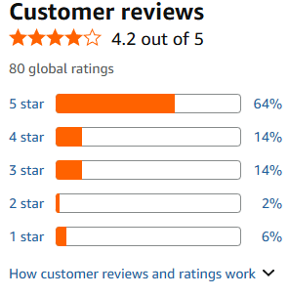
https://www.amazon.com/CHICME-Bodycon-Vacation-Embroidery-Slit-gr-L/dp/B0GFNBQC9Z/ref=sr_1_22_sspa?crid=2QIA9RG3MIZZA&dib=eyJ2IjoiMSJ9.mCKHiU7FzhsQY4c0T093N7mpTtXtlZtXBATB9eA84XudcWoiVMiEmuyn5OFU4DLPxV7qncLBHrEgnkpKkeyGudBBr0hdbaGB3PRjIyVZ2jM0Np67nb53YOGVDla628_1e5QtPMMSQ3ULpfzgEEPnbJf3IEkBJ3IaSkotF7E_o5qq4nZvARS3nRAZoJtNRQ21m1T4lhqmkMVTBqRACtKP_f4EV7DQJ5oPwZKFTauMkjOF_jCsLLxw04vnkVBKXFG0Of-71BJuzygH7B4NSb_QijYpJuMJTK2gs4_9B2WFrlM.UZ8-HVHKC5vs8MB8DLjGBzWEgVkm6z4htd-_G6SG_mc&dib_tag=se&keywords=womens%2Bdresses%2Bparty&qid=1780384763&sprefix=womens%2Bdresses%2Bpa%2Caps%2C360&sr=8-22-spons&xpid=_OlPUQsIfpuyN&sp_csd=d2lkZ2V0TmFtZT1zcF9tdGY&th=1&psc=1

06]

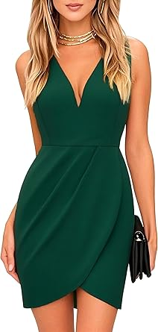
oxiuly Women's Wrap V Neck Bodycon Ruched Cocktail Party Dress Chic Church Wedding Club Pencil Dresses OX345
LKR 15,245.68LKR15,245.68

Product details
Top highlights
Fabric type
60% Viscose,35% Polyester+5% Elastane
Origin
Imported
Closure type
Zipper
Neck style
V-Neck

About this item
- Size Guide: S=US 4-6, M=US 8-10, L=US 12-14, XL=US 16. Please check the size chart before ordering!Size S:Bust(82 cm-90 cm/32.28"-35.4"), Waist(66 cm-76 cm/26"-30"), Length(88cm/34.65") Size M:Bust(87 cm-95 cm/34.25"-37.4"), Waist(71 cm-81 cm/28"-32"),Length(89 cm/35") Size L:Bust(92 cm-100 cm/36.2"- 39.4"), Waist(77 cm-87 cm/30.3"-34.25"), Length(90 cm/35.43") Size XL:Bust(98 cm-106 cm/38.6"-41.7"), Waist(83 cm-93 cm/32.7"-36.6"),Length(91 cm/35.83")
- COCKTAIL MINI CASUAL DRESSES : Women's party casual mini dresses very cute well cut and hugs your curves perfectly. Elegant women's wear to work dresses skirts flowing very pretty and accentuates your figure.This women's fit and flare summer dresses have a elegant feminine look!
- CHIC V NECK PARTY DRESSES : This is vintage mini work party wedding guest dresses. Retro women's V neck mini dress make you more feminine.The women's party cocktail club business dresses very flattering.It is the perfect length to wear out and works well for curvy girls. Good chest coverage and it doesn't show too much cleavage. Invisible zipper closure on the back to protect your skin better.
- VINTAGE CLUBWEAR: This is women's vintage swing casual party cocktail dresses. Vintage pleated 1950s black dress .The cocktail pencil sheath mini dress is elegant it self.
- CHURCH WEDDING DRESS: That could be dressed up or down depending on the occasion. Such as wear business office work, casual, partys, church, beach wedding, wedding guest, prom, cocktail, holiday, honeymoon, cruise, birthdays, dinner, summer evenings, homecoming,Graduation, party, Thanksgiving, Easter, wedding, reception, carnival, Valentine's Day, Christmas, dance party, new year, concert, anniversary, women's day.
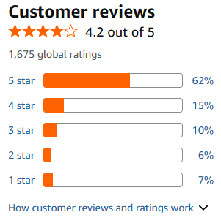
https://www.amazon.com/oxiuly-Bodycon-Cocktail-Wedding-Dresses/dp/B0B3S5XT34/ref=sr_1_29_sspa?crid=2QIA9RG3MIZZA&dib=eyJ2IjoiMSJ9.mCKHiU7FzhsQY4c0T093N7mpTtXtlZtXBATB9eA84XudcWoiVMiEmuyn5OFU4DLPxV7qncLBHrEgnkpKkeyGudBBr0hdbaGB3PRjIyVZ2jM0Np67nb53YOGVDla628_1e5QtPMMSQ3ULpfzgEEPnbJf3IEkBJ3IaSkotF7E_o5qq4nZvARS3nRAZoJtNRQ21m1T4lhqmkMVTBqRACtKP_f4EV7DQJ5oPwZKFTauMkjOF_jCsLLxw04vnkVBKXFG0Of-71BJuzygH7B4NSb_QijYpJuMJTK2gs4_9B2WFrlM.UZ8-HVHKC5vs8MB8DLjGBzWEgVkm6z4htd-_G6SG_mc&dib_tag=se&keywords=womens%2Bdresses%2Bparty&qid=1780384763&sprefix=womens%2Bdresses%2Bpa%2Caps%2C360&sr=8-29-spons&xpid=_OlPUQsIfpuyN&sp_csd=d2lkZ2V0TmFtZT1zcF9tdGY&th=1&psc=1

07]

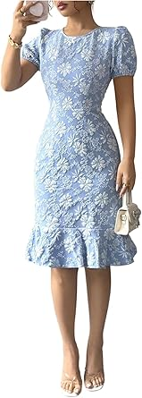
SOLY HUX Women's Puff Sleeve Ruffle Dress Elegant Jacquard Crew Neck Bodycon Going Out Dresses
LKR 14,251.18LKR14,251.18

Product details
Top highlights
Fabric type
100% Polyester
Care instructions
Machine Wash
Origin
Imported
Closure type
Zipper

About this item
- Fabric has no stretch, but it is soft and skin friendly, comfy to wear
- Design: Floral jacquard, ruffle hem, short sleeve, round neck, high waist, slim fit, knee length dress, puff sleeve dress for women
- Occasions: The ruffle dress is fit for romantic date, dinner, birthday, concert, afternoon tea, garden party, wedding guest, banquet, weekend
- Match: Pair this elegant dress with high heels, sandals, clutch purse, and delicate earrings for a classic look
- Size recommendation: Please refer to size chart which we provide in our photos (The product measurement is clothes size, NOT body measurement)
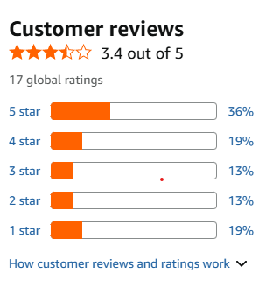
https://www.amazon.com/SOLY-HUX-Elegant-Jacquard-Bodycon/dp/B0F6SHYV6D/ref=sr_1_91?crid=2QIA9RG3MIZZA&dib=eyJ2IjoiMSJ9.PMTErOdiYRPNyG6F5V_sRDxrtksCGqy70esdT4_H_mCClNh6T5apuqRJ4xxjgi7gFg1ZKA7lBKlADp5soXMnKQk6HiroidEM2OoX__FJumLjfcM1zMafm1jaFeV41dWgjYM4IHBbnKYM_GsQBxZE7YgTGxjSAz135UkNK3BhRv-q0Q4_AaW2USTeM7PvKM5TADNWNK7qPYURbZrBSUsTWoDe9Vve-HjoBkvEtIJnPBnkXJkgInq57kVJ85XKBR4eChsQS7qzyNVCn52oIz4jdTY-7Y3VBDKYl9J_5PoQPjs.DuJ9o56RCUajIeFt9svD25hvU1oW1YmFBM5NL0GJ3jk&dib_tag=se&keywords=womens%2Bdresses%2Bparty&qid=1780386480&sprefix=womens%2Bdresses%2Bpa%2Caps%2C360&xpid=_OlPUQsIfpuyN&th=1&psc=1
08]

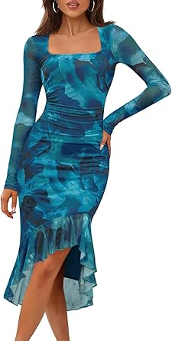
MEROKEETY Women's 2026 Wedding Guest Dress Bodycon Long Sleeve Square Neck Ruched Mesh Cocktail Party Holiday Midi Dresses
LKR 7,289.68 with 42 percent savings-42% LKR7,289.68
List Price: LKR 12,593.68List Price: LKR12,593.68

Product details
Top highlights
Fabric type
95% Polyester, 5% Elastane
Care instructions
Machine Wash
Origin
Imported
Closure type
Pull On

About this item
- Size Guide: S=US(4-6), M=US(8-10), L=US(12-14), XL=US(16-18). This mesh midi dress is made of mesh double lined fabric, high quality, soft, lightweight, skin-friendly and stretchy
- Features: The vintage long dress features long sheer mesh sleeve, square neck, slim fit, double layered, back zipper, ruched detail gathering at waist, ruffle hem, midi length, floral printed, breathable but not see-through, irregular high-low ruffle hem, body con dress, sexy club party dress, date night dress
- Match: Ladies sexy long sleeve bodycon dress can match with high heels, earrings and necklace, handbags to create a glamorous looks. The irregular hem design elegantly sways in the wind, adding more charm to you and attracting countless eyes at parties and dances
- Occasions: Sexy fall dress for women is suitable for going out, date night,d inner, birthday, wedding, graduation, neon night out, homecoming, club, clubwear, home, shopping, halloween, prom, street, anniversaries
- Washing Instruction: Hand/Machine washable with cold water recommended, do not bleach, iron in low, hang or line to dry
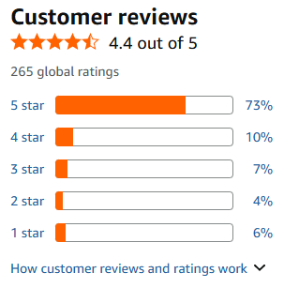
https://www.amazon.com/MEROKEETY-Dress-Long-Sleeve-Midi/dp/B0FS7697HY/ref=sr_1_108?crid=2QIA9RG3MIZZA&dib=eyJ2IjoiMSJ9.QcOCsHm4UOfKgSJVkVT7v4js0zSNZCa8VpqPYG6F6t2ulH5c1DxJTfBkdek_YrrKWwV1XHhczEqrJevKIXVszQ1S3_Im-RbDR0KtSMTvrv7nfCR8MKyxUaP0Bpsfecg7lEM3m46e6fJ_KpbBoZ0L5yLNmBfQaiqhO3chq8WA2zmonLXOhotRqj1cPgCGtsMDIc0wnM0vxJCppIiWxjIexjBV3Fjru7e2u2KRFlhYd9VIDtzVB4di1lFamg4nBF5HMtXXgQbvZpLlJsqfLVqIVpOyziVVh4-Jp4R_GxMjFjU.eQ14BdtURDxnKVgQVApFYQlTtxj-GC6_C7I_uBzjg00&dib_tag=se&keywords=womens%2Bdresses%2Bparty&qid=1780386749&sprefix=womens%2Bdresses%2Bpa%2Caps%2C360&xpid=_OlPUQsIfpuyN&th=1&psc=1

09]

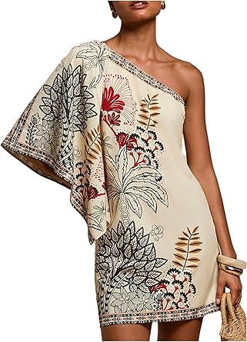
Floerns Women's Floral One Shoulder Mini Dress Dolman Sleeve Vacation Tunic Dresses
LKR 8,284.18 with 17 percent savings-17% LKR8,284.18
List Price: LKR 9,941.68List Price: LKR9,941.68

Product details
Top highlights
Fabric type
95% Polyester, 5% Elastane
Care instructions
Machine Wash
Origin
Imported
Closure type
Pull On

About this item
- Material: Non stretch fabric, but very soft, breathable and comfy to wear
- Features: Dolman sleeve, one shoulder, floral print, tunic dress, summer mini dress for women
- Occasion: Suitable for casual occasion, beach, vacation, work, travel, basic trip, outdoor activities, parties or daily wearing
- Garment Care: Machine washable with cold water
- Size: Please refer to the Product Description as below(The measurements is product size, NOT body size)
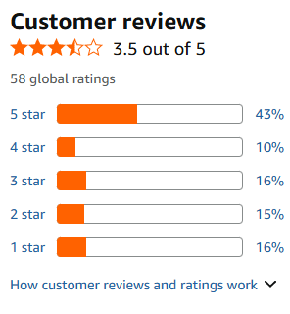
https://www.amazon.com/Floerns-Womens-Shoulder-Vacation-Dresses/dp/B0GJSDB8D3/ref=sr_1_104?crid=2QIA9RG3MIZZA&dib=eyJ2IjoiMSJ9.suqpqqcgcivdeQvdMB7uZ72noO9diCszc_v-YV2MC6CpuvkY5sF3mxkGXiaqjSncbPBwyYLsVX0RVl5IRvW_5o-3Ww1VmKZtgfwkhG52EbMA6k89aYCzWlCfZMSnz7AAKUrMd-ef9vOYHnt5mw4ZWh80mBubudHlepoy-AlxtlRiBTpbKLyXrJGnFI28_t-4s9HBm-768lm2nGlKOkX819b7K-OlHpdXsNvKmtw7hYfQfL9NXZcy2jOSkPB6NU2iC75uKC-b8sdMUkHiS1OR8QgPmT5eYPKQrIXn1IkyuCA.l0N4KqhAd6kraJ6elg51LEslhBt0H-stek4OiwtM_Sc&dib_tag=se&keywords=womens%2Bdresses%2Bparty&qid=1780387026&sprefix=womens%2Bdresses%2Bpa%2Caps%2C360&xpid=_OlPUQsIfpuyN&th=1&psc=1

10]

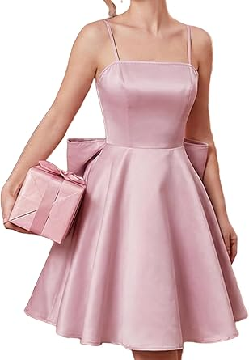
WDIRARA Women's Satin Bow Homecoming Dresses Spaghetti Strap Wedding Guest Gown Summer Mini Dress
LKR 13,256.68LKR13,256.68
LKR 23,974.08 Shipping & Import Charges to Sri Lanka

Product details
Top highlights
Fabric type
100% Polyester
Care instructions
Machine Wash
Origin
Imported
Closure type
Pull On

About this item
- Features: sleeveless cami dress, features with lace up tie back, big bow, spaghetti strap, ruffle hem
- Fabric: Made of 100% polyester, lightweight, soft and comfortable
- Occasion: Good choice for cocktail, party, club, night out, formal occasion, evening, brunch, birthday
- Match: Nice to wear with sandals, high heels, boots, handbags, purses to create an attractive look
- Please note: The size of this product is relatively small. It is recommended to choose the appropriate size according to the size chart
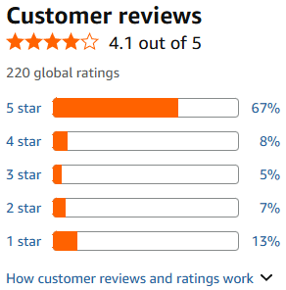
https://www.amazon.com/WDIRARA-Homecoming-Dresses-Elegant-Spaghetti/dp/B0DCBC3X8D/ref=sr_1_121?crid=2QIA9RG3MIZZA&dib=eyJ2IjoiMSJ9.GMtPKCHF-9zolaT8ldeV32h0t7IYu_QDFxV1hwCai8iunVmyzFnLiY8r_G4B1B7yNBBcVqtXwLZLOEWMAnHf2_cFd-rMwHeW_ZTQmoSLJZeYAkXrNmhXEVITRfoPdvWmmErazGNxNgGv6-QbOeIdn84j_qqTIUrE_kZs_SwuFOJqmvlUyqeiIAOIrWXo0TQCvOM8kZessEsM5IicqtcRKmRV89j12suTgCK_yCRnVLMARXiGdWsO6eg-3PG7_aLwwX4JkwqfVghtpy90YZYqDTpw3Oswit3yjR6JzGFWVJQ.4pIJ7uxXYrhXTUUQoHYL9cU8NNNDgdinxVXoDPQiWz8&dib_tag=se&keywords=womens%2Bdresses%2Bparty&qid=1780387186&sprefix=womens%2Bdresses%2Bpa%2Caps%2C360&xpid=_OlPUQsIfpuyN&th=1&psc=1

